Terraform Task 1
- Install Terraform on your PC
Go to browser install terraform for windows
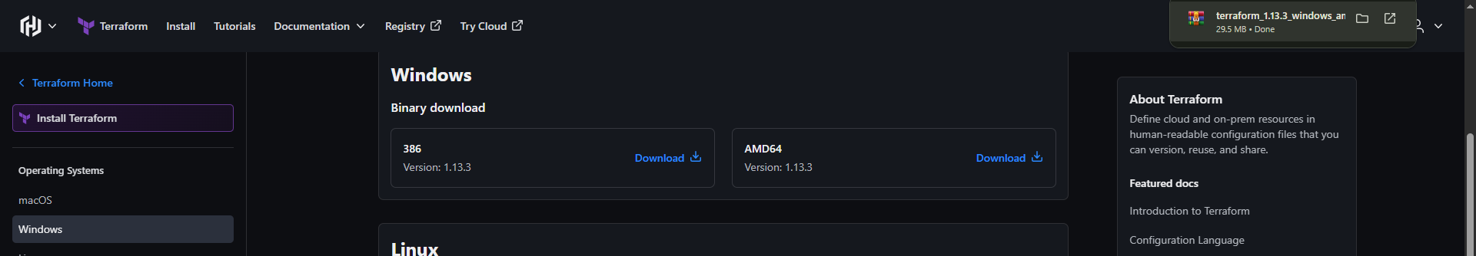

It will install .zip folder
Extract terraform.exe
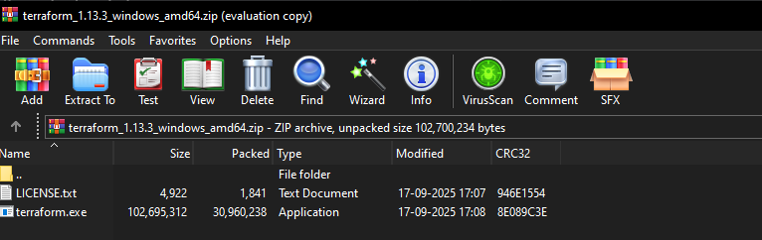
Add Terraform to System PATH
This makes Terraform available from anywhere in Command Prompt
or PowerShell.
1. Go to search and check for Edit Environment Variable
2. Go to Advanced tab → click Environment Variables
3.In System variables, scroll and select Path → click Edit
4. Click New and add
5. C:\Terraform
6. Click OK on all windows to save
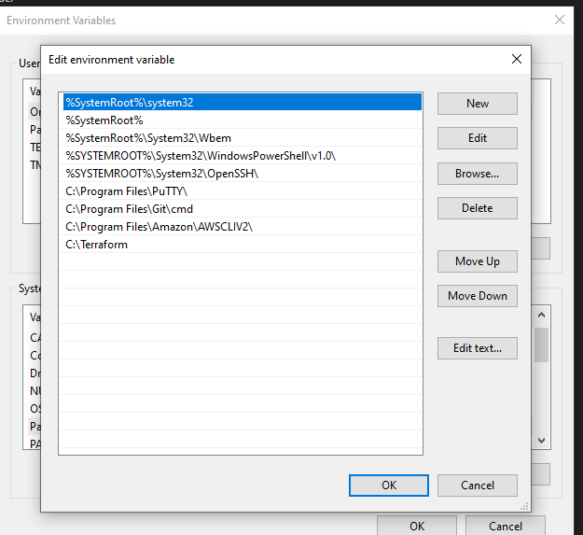
Verify Installation
Run: and check the version of terraform
terraform –version
Installed sucessfully
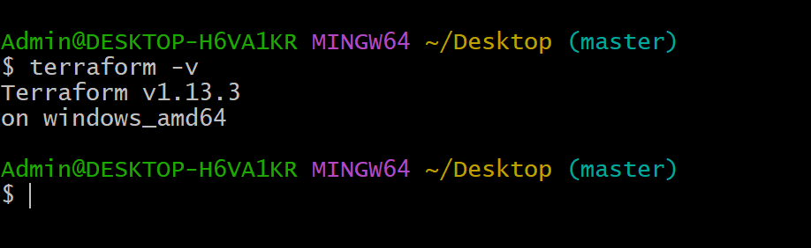

- Execute all the templates shown in video.
Step 1:
Create a folder name it Terraform (Directory)
Open in VS code In this create new file name it filenewfilesave as (main.tf)
Write a basic code
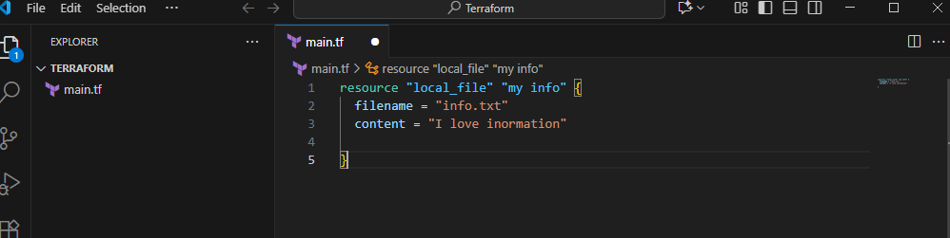

Step 2
To execute terraform template click on terminal
The location should be same
Command terraform init (it will initialize to provider)
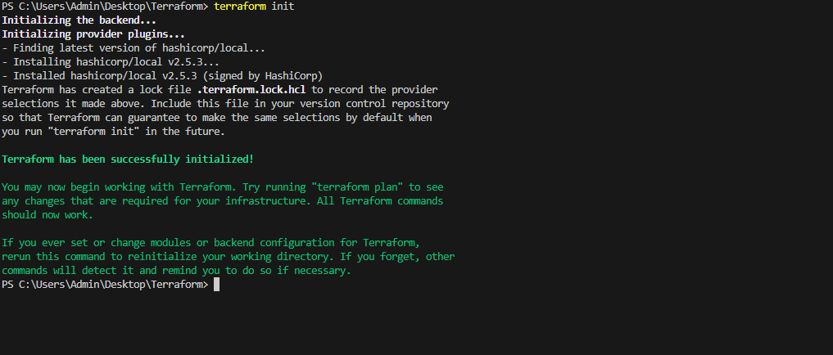

Terraform apply
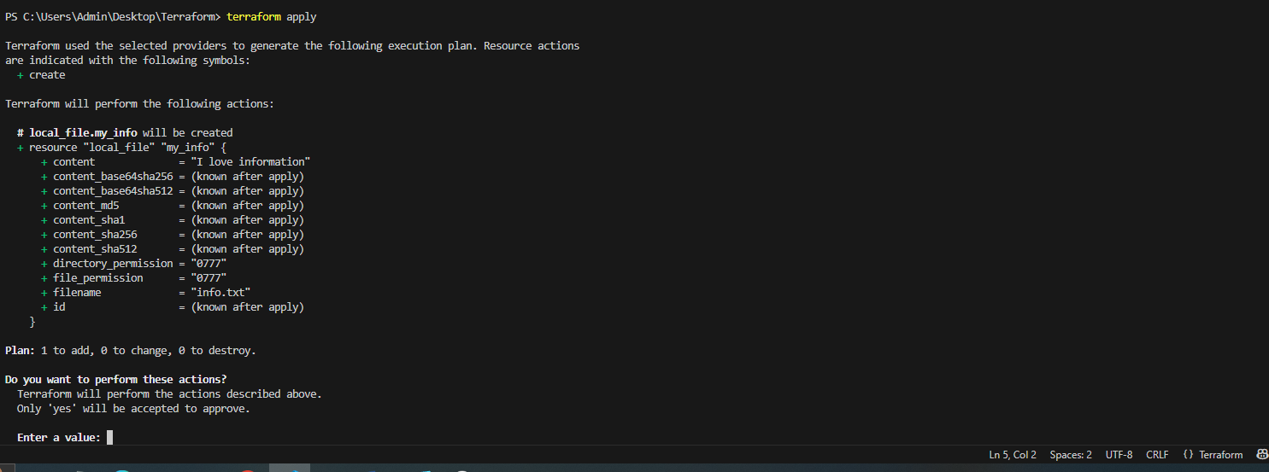
Terraform plan
Press yes
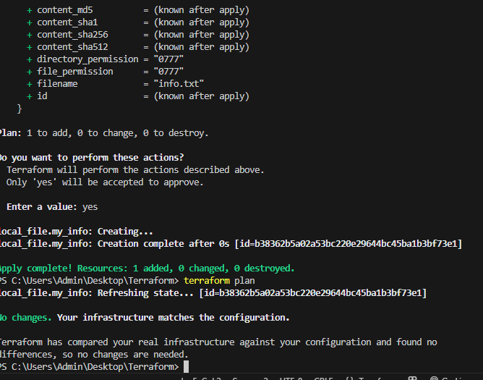
It will create one file

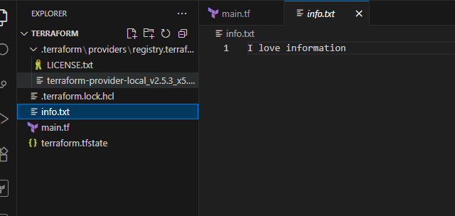

To delete
Terraform destroy
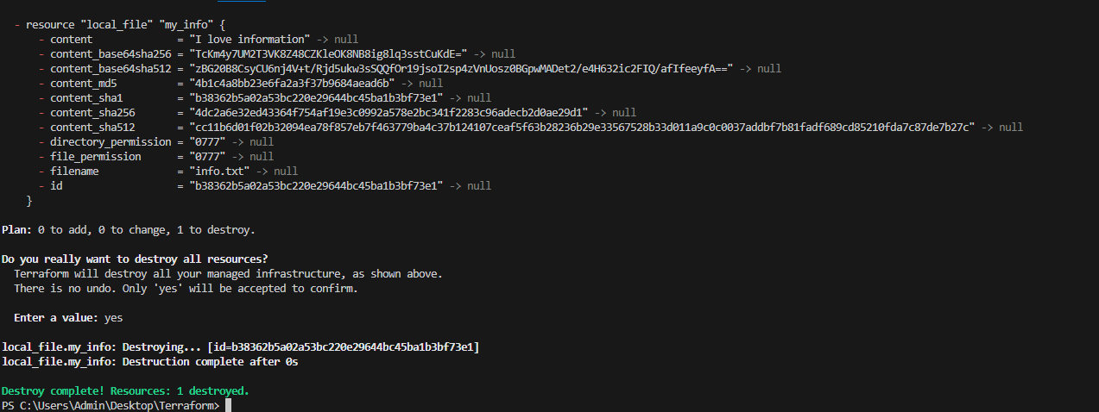create one more resources
Terraform init
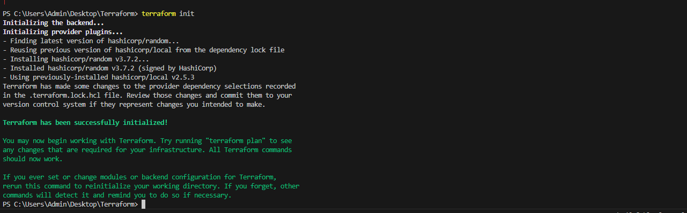
Terraform plan
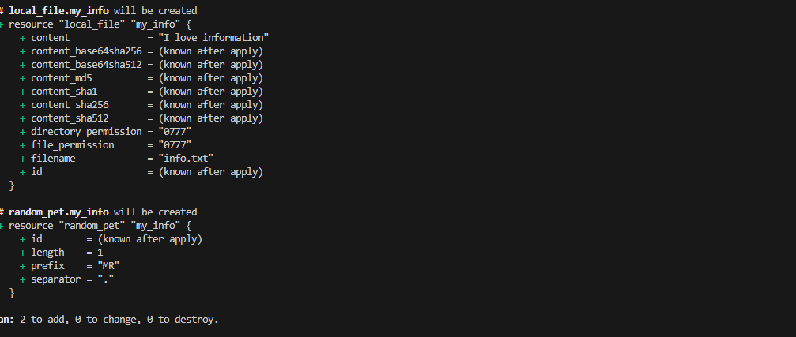terraform apply

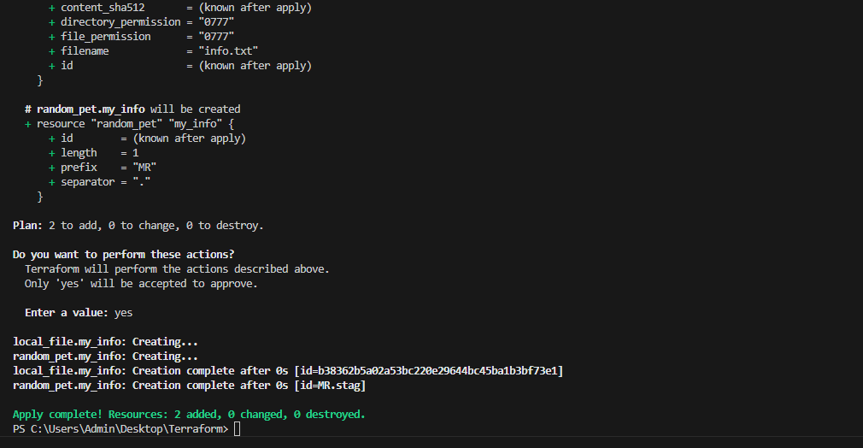
Terraform format(its automatically set our syntax)
Terraform fmt
3) Note down below points,
Terraform Init
Terraform Plan
Terraform Apply
Terraform Provider
Terraform Init:
Command: terraform init
Purpose:
Initializes a Terraform working directory.
Downloads required providers and modules.
Creates a hidden .terraform folder to manage plugins.
You must run this once per project (or after changing providers).

Terraform Plan
Command: terraform plan
Purpose:
Shows the execution plan before making any changes.
Compares your configuration (.tf files) with the real infrastructure.
Helps verify what will be created, modified, or destroyed.
Safe to run multiple times (doesn’t change resources).
Terraform Apply
Command: terraform apply
Purpose:
- Executes the actions from the plan.
- Actually creates, updates, or deletes resources.
- Terraform will ask for confirmation (yes) before applying.
After running, infrastructure is live.
Terraform Provider
A plugin that lets Terraform interact with cloud platforms, SaaS, or
APIs.
Example providers: aws, azurerm, google, kubernetes, dockeer
- Integrate a sample Terraform template in Jenkins.
Make sure these are ready:
✅ Jenkins installed (and running)
✅ Terraform installed on the Jenkins node
✅ Git repository containing your Terraform template (e.g., main.tf)

Install Terraform plugin
Goto Jenkins pluginsterraform plugin
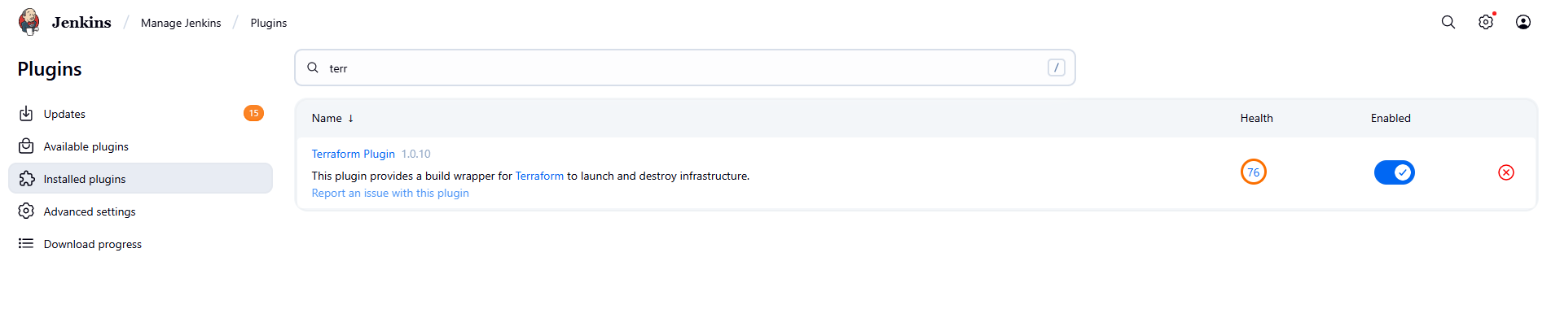
In Jenkins server install terraform
wget
https://releases.hashicorp.com/terraform/1.9.8/terraform_1.9.8_linux_amd64.zip
unzip terraform_1.9.8_linux_amd64.zip
sudo mv terraform /usr/local/bin/
terraform –version
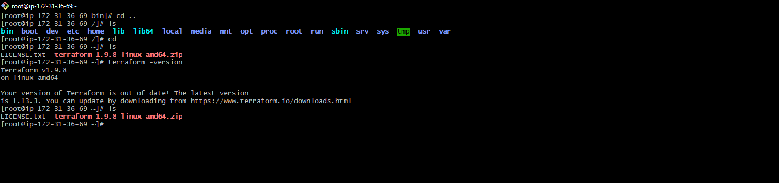
In git create one new repo
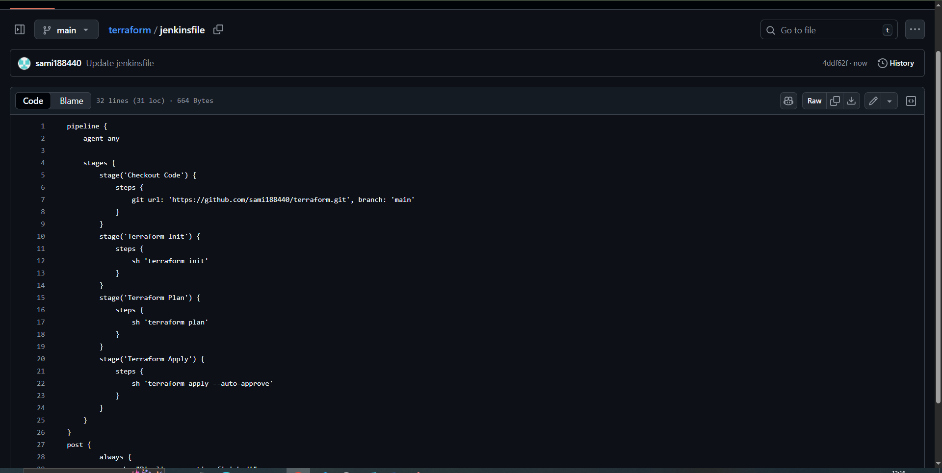
In Jenkins create a job with pipeline
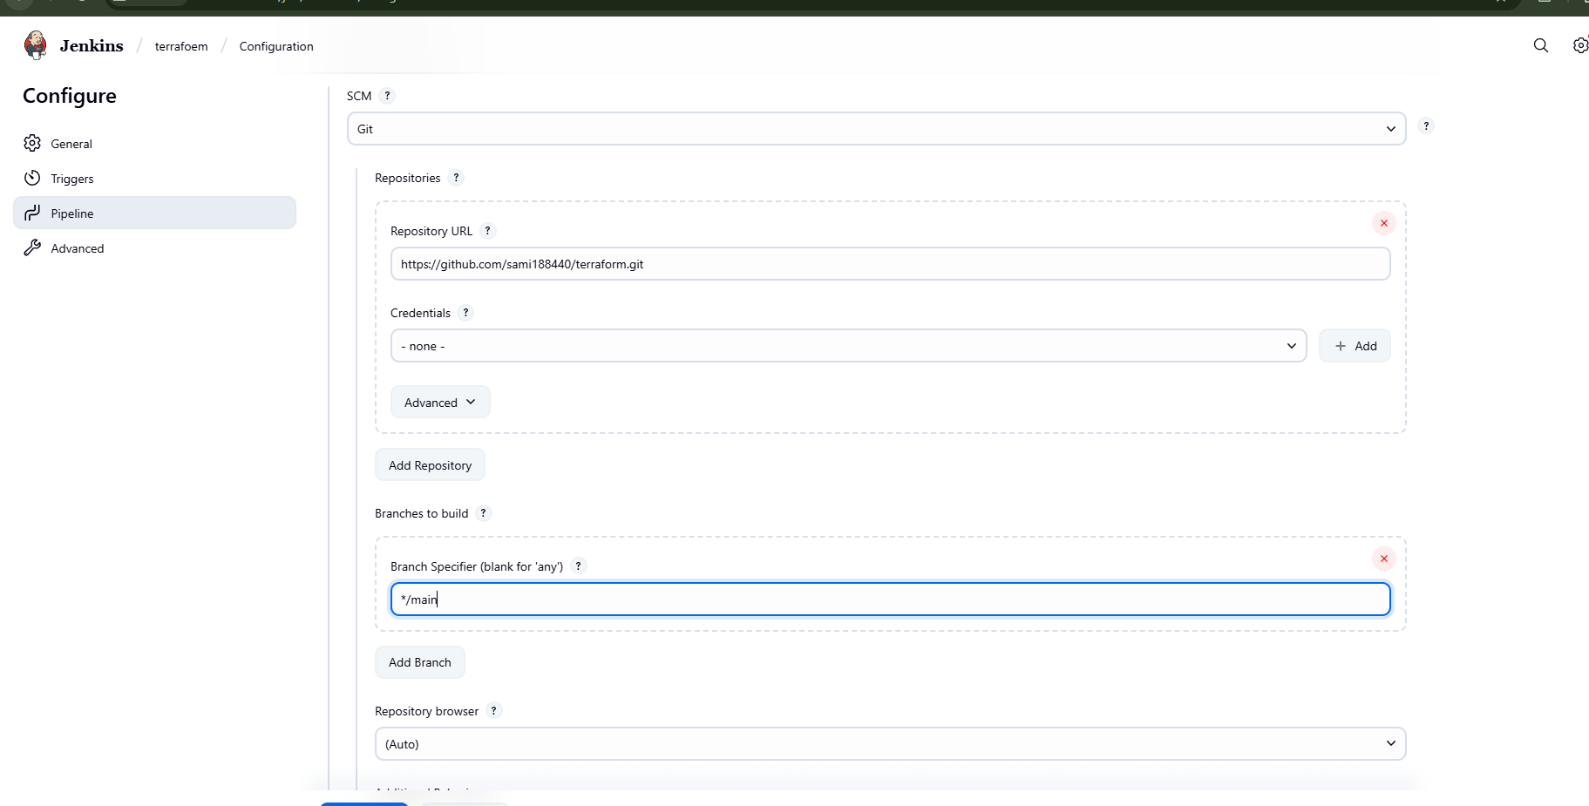
Save and buildnow
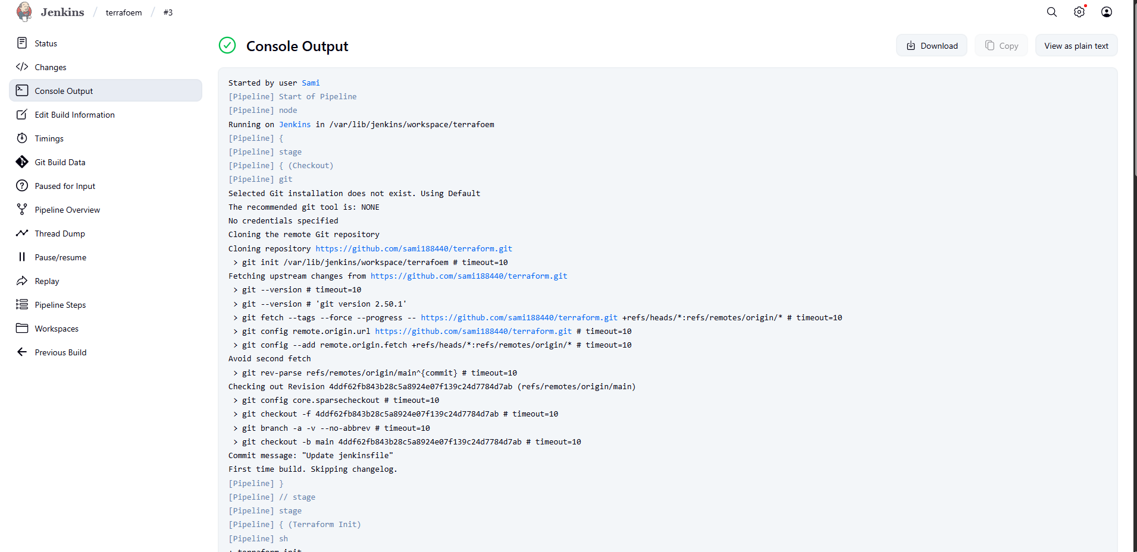
Go to Jenkins ec2 cd /var/lib/Jenkins/workspace
